This project is a bank System using 7 classes plus a main class. The classes are Person(super class), Client, Employee, normalClient, VipClient, Manager and Accountant. We use the decorator design pattern to make the project simpler and improve the user interface. The purpose of this project is to provide a convenient banking experience to Clients where they can withdraw and deposit money, take or pay back loans and check their current balance. It also manages employees and shows their experience levels and keeps track of how many managers are there and their information. It utilizes files to keep track of employees and clients so we can add people and information as we please.

The functions available in this system are:

* To add Employees and Clients with their properties
* To show clients data for accountants and show accountants data to managers
* To calculate the bonuses and salaries given to different employees
* To provide basic banking functions for clients like withdraw, deposit, take loan, pay loan, check balance and see their wait time, with a difference between normal and vip clients.
* To keep track of work achieved by both accountants and managers, seeing how many accounts they opened, how many transactions they fulfilled, how many warning they got and if they will get any bonuses.

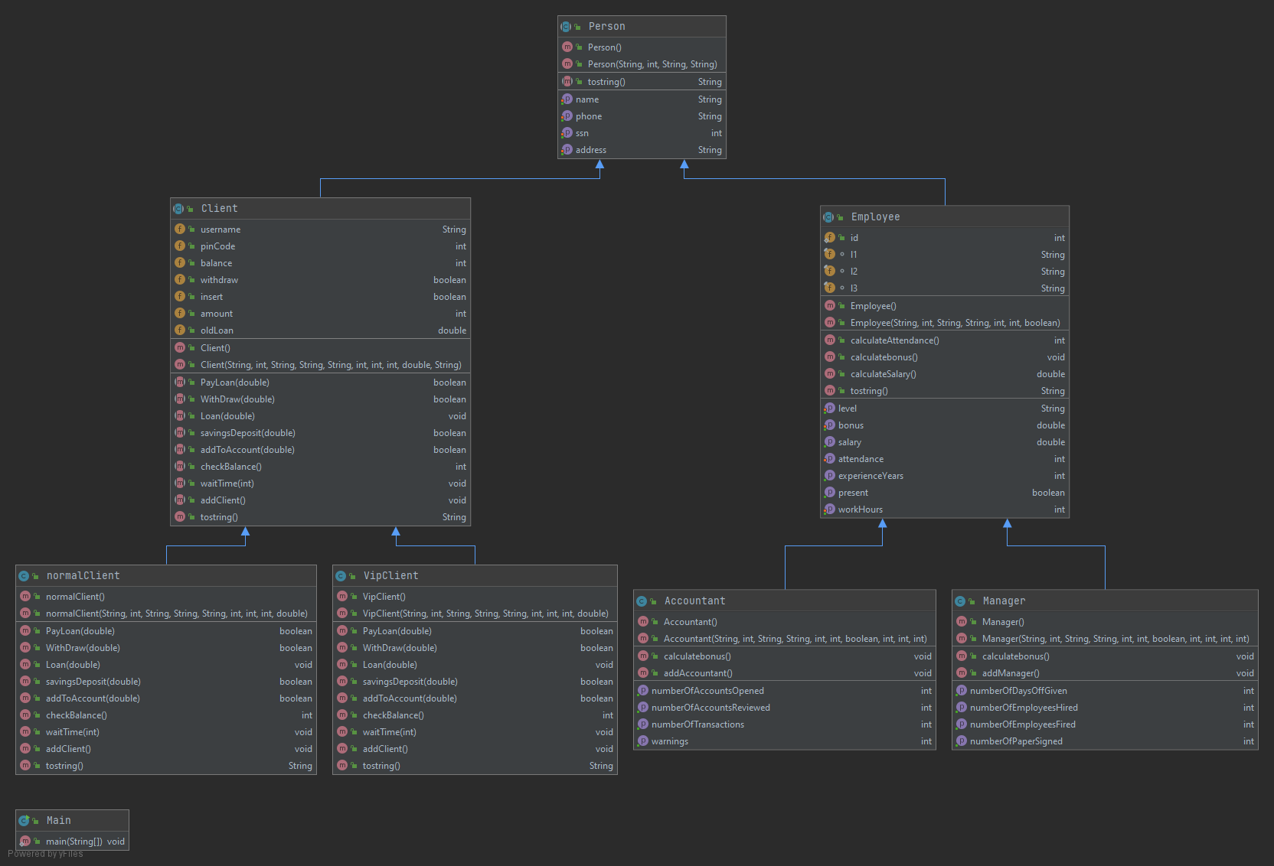

Project done by:

Habiba Khaled Hassan Derbala 18100572

Youssef Hatem Seif